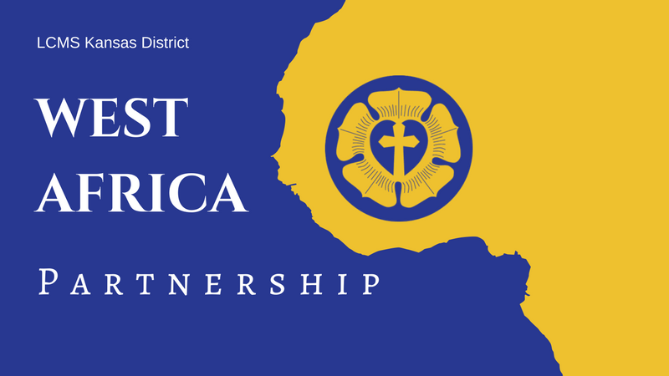
LCMS Kansas District
2026 Pentecost Offering
Weekend of May 24, 2026
Announcements & Collect

Full-Length Announcement
Modify as needed (e.g., with details about your congregation’s participation) for newsletters, bulletins, emails, social media posts, and/or announcement slides.

2026 Kansas District Pentecost Offering: Supporting Theological Education in Guinea and West Africa!

For 29 years, LCMS Kansas District congregations have supported the growth of God’s kingdom in Guinea and West Africa.

Six students are currently enrolled in the pastoral program for the 2025-2026 academic year at the Centre Luthérien d'Études Théologiques (CLET) Guinea seminary in Guéckédou. This is the second year of classes using the newly constructed seminary buildings and campus grounds.

Other West Africa updates include The Evangelical Lutheran Church of Guinea (ELCG) aiding those affected by a tornado in the Lutheran community of Gbandekamadou, in April 2025. As of March 2026, several of the damaged houses were under construction, including the village church. More than 122 people from the 12 affected families have received assistance. In addition, over 120 patients and 200 prisoners in various locations were visited by the ELCG in the past year. The church body makes monthly visits to prisons and hospitals to share the Gospel, pray, and tend to needs like food, water, or medicine. There are also currently six students at CLET-Dapaong, and three of the students will complete their training in May.

An abundance of mission work is taking place in Guinea and West Africa, and there is still much to be done! Please consider participating in this year’s Pentecost Offering, and supporting the great work being accomplished. The offering will be used to continue supporting operational costs of the Guinea seminary, as well as the provision of Lutheran education and resources to the people of Guinea and West Africa.

To learn more or make an online gift, visit the West Africa/Guinea page on the District website, https://kslcms.org/guinea-westafrica. If you would rather donate by mail, you can send a check with “Pentecost Offering” in the memo line to the LCMS Kansas District (1000 SW 10th Ave., Topeka, KS 66604-1104).

Suggested Collect for Pentecost Sunday
Lord of the Harvest, You invite us to ask You to send workers into the Harvest Field according to Your gracious will. Grant pastors, O Lord, not only for our congregations in Kansas, but also for the people of Guinea who are made faithful through the study of Your Word. Give us generous hearts to support the work. And bless Your servants to proclaim Your excellencies to those near and far that Your Kingdom be extended and Your Name glorified; through Jesus Christ, our Lord. Amen!

Shortened Announcement
Modify as needed (e.g., with details about your congregation’s participation) for newsletters, bulletins, emails, social media posts, and/or announcement slides.

2026 Kansas District Pentecost Offering, Weekend of May 24

Our Christian brothers and sisters in Guinea and West Africa need your prayers and gifts! There is much to be done for continued support of operational costs for the seminary and Lutheran education in Guinea and West Africa. To learn more or make an online gift, visit the West Africa/Guinea page on the District website, https://kslcms.org/guinea-westafrica.

Suggested Collect for Pentecost Sunday
Lord of the Harvest, You invite us to ask You to send workers into the Harvest Field according to Your gracious will. Grant pastors, O Lord, not only for our congregations in Kansas, but also for the people of Guinea who are made faithful through the study of Your Word. Give us generous hearts to support the work. And bless Your servants to proclaim Your excellencies to those near and far that Your Kingdom be extended and Your Name glorified; through Jesus Christ, our Lord. Amen!

