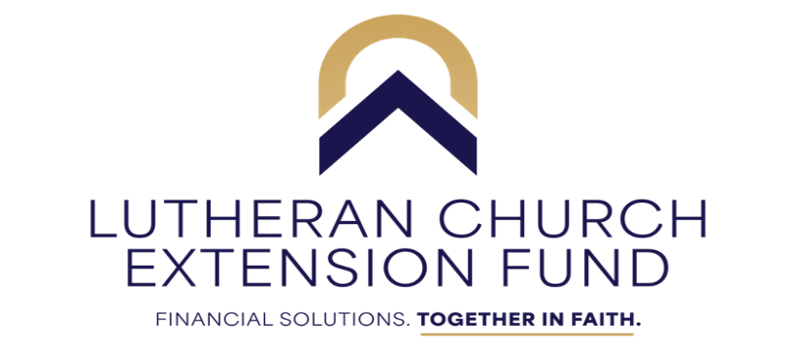

May 5, 2025

To: Kansas & Oklahoma Churches, Schools and RSO’s

RE: LCEF Outreach Ministry Grants

The Lutheran Church Extension Fund is a nonprofit ministry of the church. LCEF is blessed by strong investors and faithful borrowers. It is a partnership that is working and through the continued blessings of our Lord, LCEF is pleased to make available $32,000 in ***LCEF*** ***Outreach Ministry Grants*** to congregations, schools and other LCMS organizations within the Kansas and Oklahoma Districts.

Grants will be awarded in amounts up to $500.00 (You specify the amount on your application). Matching funds and cooperative efforts with other groups are highly desirable in this effort. *NOTE* Final awards will be based on the number of applications received.

LCEF is making funds available to help make your local outreach event a reality. There will be a limit of one (1) application per congregation, school, or Recognized Service Organization. If you want to use the grant for multiple events, be sure and include details on each event in your one (1) application.

We ask that you pass copies of this material on to:

Church Pastor/Church Leadership (President/Head Elder)

Day School Principal/Director/Headmaster/Preschool Director

We would prefer that you complete this application online at the link below: <https://form.jotform.com/250964474655064>

If you prefer a printed copy of the application to complete by hand, please contact Tami Lierz at [tami@kslcms.org](mailto:tami@kslcms.org).

Apply today, before time runs out—the deadline is: Friday, June 13, 2025. Grants will be awarded by Friday, June 27, 2025.

Questions can be directed to Jeffrey Maltz at 785-230-4112 or Tami Lierz at 785-357-4441 x 5001, or email [jeffrey.maltz@lcef.org](mailto:jeffrey.maltz@lcef.org) or [tami@kslcms.org](mailto:tami@kslcms.org). We look forward to reviewing your submission and pray God’s blessings upon your ministry.

Sincerely,

Jeffrey H. Maltz

Vice President of LCEF, Kansas/Oklahoma Districts