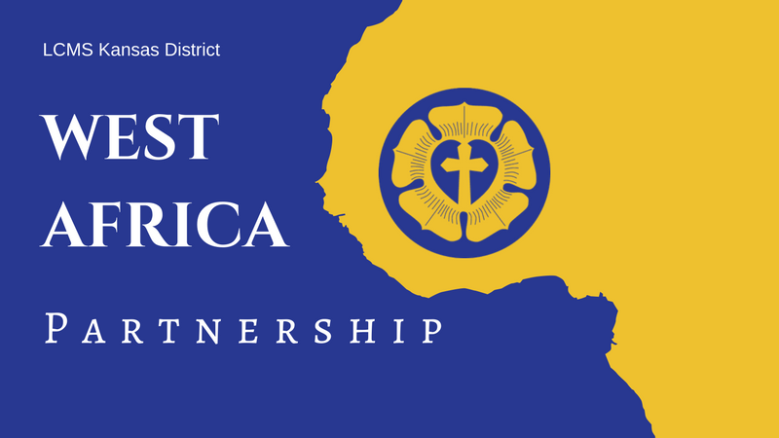LCMS Kansas District **2025 Pentecost Offering**

June 8, 2025

Announcements & Collect

**Full-Length Announcement**

*Modify as needed (e.g., with details about your congregation’s participation) for newsletters, bulletins, emails, social media posts, and/or announcement slides.*

**2025 Kansas District Pentecost Offering: Supporting Theological Education in Guinea and West Africa!**

For 28 years, LCMS Kansas District congregations have supported the growth of God’s kingdom in Guinea and West Africa. Through the 2024 Pentecost Offering and designated funds, $50,000 was sent by the Kansas District in support of the West Africa partnership!

Construction was completed on the two main seminary buildings in Guinea! Six students are currently enrolled in the pastoral program for the 2024-2025 academic year at the Centre Luthérien d'Études Théologiques (CLET) Guinea seminary, within the Evangelical Lutheran Church of Guinea-Conakry. This is the first year of classes with the students using the newly constructed seminary buildings and campus grounds. **Praise God for His provisions!**

Other West Africa updates include reports of The Christ Evangelical Lutheran Church in Sierra Leone celebrating new graduates who are equipped to go and preach, teach, and baptize in the name of the Father, Son, and Holy Spirit; a growing number of seminarians and deaconess trainees currently being trained at the Lutheran Theological Seminary in Ghana; seminary students at the Jonathan Ekong Memorial Lutheran Seminary in Nigeria manage a fish farm for their own meals, to increase support from the LCMS, and a faith testimony shared by one of the seminary students at CLET-Togo in Dapaong.

**An abundance of mission work is taking place in Guinea and West Africa, and there is still much to be done!** Please consider participating in this year’s Pentecost Offering, and supporting the great work being accomplished. The offering will be used to continue supporting operational costs of the Guinea seminary, as well as the provision of Lutheran education and resources to the people of Guinea and West Africa.

To learn more or make an online gift, visit the West Africa/Guinea page on the District website, [**https://kslcms.org/guinea-westafrica**](https://kslcms.org/guinea-westafrica). If you would rather donate by mail, you can send a check with “Pentecost Offering” in the memo line to the LCMS Kansas District *(1000 SW 10th Ave., Topeka, KS 66604-1104).*

**Suggested Collect for Pentecost Sunday**

Lord of the Harvest, You invite us to ask You to send workers into the Harvest Field according to Your gracious will. Grant pastors, O Lord, not only for our congregations in Kansas, but also for the people of Guinea who are made faithful through the study of Your Word. Give us generous hearts to support the work. And bless Your servants to proclaim Your excellencies to those near and far that Your Kingdom be extended and Your Name glorified; through Jesus Christ, our Lord. Amen!

**Shortened Announcement**

*Modify as needed (e.g., with details about your congregation’s participation) for newsletters, bulletins, emails, social media posts, and/or announcement slides.*

**2025 Kansas District Pentecost Offering, June 8**

Through the 2024 Pentecost Offering and designated funds, $50,000 was sent by the Kansas District in support of the West Africa partnership! Thank you so much for your support! **Our Christian brothers and sisters in Guinea and West Africa still need your prayers and gifts!** There is much to be done for continued support of operational costs for the seminary and Lutheran education in Guinea and West Africa. To learn more or make an online gift, visit the West Africa/Guinea page on the District website, [**https://kslcms.org/guinea-westafrica**](https://kslcms.org/guinea-westafrica).

**Suggested Collect for Pentecost Sunday**

Lord of the Harvest, You invite us to ask You to send workers into the Harvest Field according to Your gracious will. Grant pastors, O Lord, not only for our congregations in Kansas, but also for the people of Guinea who are made faithful through the study of Your Word. Give us generous hearts to support the work. And bless Your servants to proclaim Your excellencies to those near and far that Your Kingdom be extended and Your Name glorified; through Jesus Christ, our Lord. Amen!