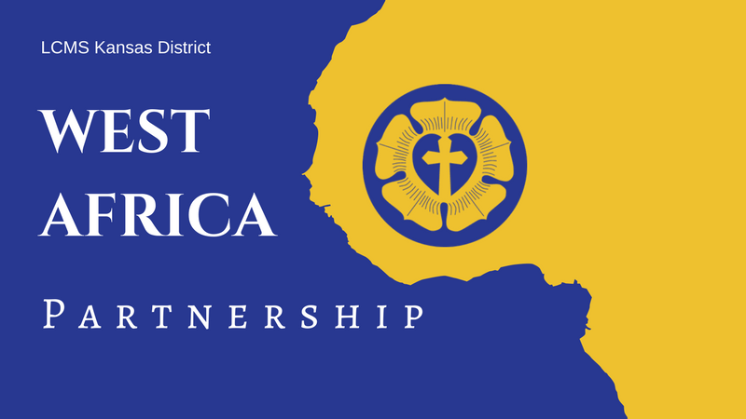
LCMS Kansas District
2024 Pentecost Offering
May 19, 2024
Announcements & Collect

Full-Length Announcement
Modify as needed (e.g., with details about your congregation’s participation) for newsletters, bulletins, emails, social media posts, and/or announcement slides.

2024 Kansas District Pentecost Offering: Supporting Theological Education in Guinea and West Africa!

For 27 years, LCMS Kansas District congregations have supported the growth of God’s kingdom in Guinea and West Africa. Through the 2023 Pentecost Offering and designated funds, a total of $50,000 was sent by the Kansas District in support of the West Africa partnership!

Construction began in April 2023 on the two main seminary buildings in Guinea, and progress continues. For the 2023-2024 academic year, the current group of students and supervisors remains in the existing church facility while construction is completed. Praise God for His provisions!

Other updates from Guinea and West Africa include repairs for the Saint Paul School near Guéckédou, Guinea, after suffering damage from violent storms in May 2023. LCMS Disaster Relief and the Evangelical Lutheran Church in Guinea (ELCG) provided repair work to the school. The Care of Souls Hospital & Prison Ministry continues to meet the material and financial needs of patients and prisoners by providing food, clothes, Bibles, mats, soap, and medical supplies.

An abundance of mission work is taking place in Guinea and West Africa, and there is still much to be done! Please consider participating in this year’s Pentecost Offering, and supporting the great work being accomplished. The offering will be used to continue supporting the Guinea seminary, as well as the provision of Lutheran education and resources to the people of Guinea and West Africa.

To learn more or make an online gift, visit the West Africa/Guinea page on the District website, https://kslcms.org/guinea-westafrica. If you would rather donate by mail, you can send a check with “Pentecost Offering” in the memo line to the LCMS Kansas District (1000 SW 10th Ave., Topeka, KS 66604-1104).

Suggested Collect for Pentecost Sunday
Lord of the Harvest, You invite us to ask You to send workers into the Harvest Field according to Your gracious will. Grant pastors, O Lord, not only for our congregations in Kansas, but also for the people of Guinea who are made faithful through the study of Your Word. Give us generous hearts to support the work. And bless Your servants to proclaim Your excellencies to those near and far that Your Kingdom be extended and Your Name glorified; through Jesus Christ, our Lord. Amen!

Shortened Announcement
Modify as needed (e.g., with details about your congregation’s participation) for newsletters, bulletins, emails, social media posts, and/or announcement slides.

2024 Kansas District Pentecost Offering, May 19

Through the 2023 Pentecost Offering and designated funds, a total of $50,000 was sent by the Kansas District in support of the West Africa partnership! Thank you so much for your support! Our Christian brothers and sisters in Guinea and West Africa still need your prayers and gifts! There is much to be done for continuing support of the seminary and Lutheran education. To learn more or make an online gift, visit the West Africa/Guinea page on the District website, https://kslcms.org/guinea-westafrica.

Suggested Collect for Pentecost Sunday
Lord of the Harvest, You invite us to ask You to send workers into the Harvest Field according to Your gracious will. Grant pastors, O Lord, not only for our congregations in Kansas, but also for the people of Guinea who are made faithful through the study of Your Word. Give us generous hearts to support the work. And bless Your servants to proclaim Your excellencies to those near and far that Your Kingdom be extended and Your Name glorified; through Jesus Christ, our Lord. Amen!

