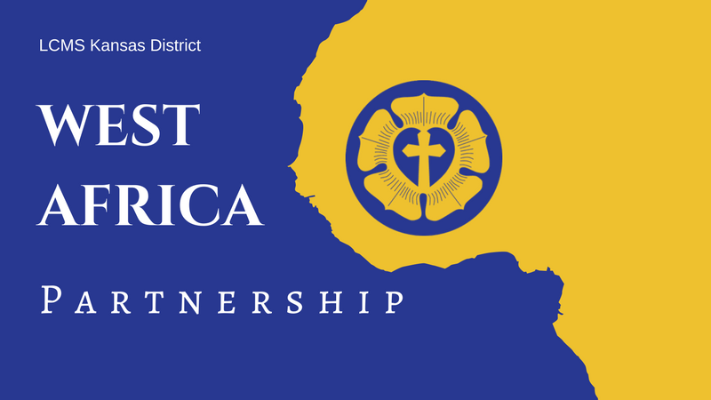LCMS Kansas District **2023 Pentecost Offering**

May 28, 2023

Announcements & Collect

**Announcements** *Modify as needed (e.g., with details about your congregation’s participation) for newsletters, bulletins, emails, social media posts, or announcement slides.*

**2023 Kansas District Pentecost Offering: Supporting Theological Education in Guinea and West Africa!**

For 26 years, LCMS Kansas District congregations have supported the growth of God’s kingdom in Guinea and West Africa. Last year we celebrated the 25th Anniversary of this partnership and put forth the goal of raising $25,000 for the new CLET-Guinea seminary. **By God’s grace, since the start of last year’s offering over $55,000 was raised for the seminary in Guinea!**

Much was accomplished last year in Guinea and West Africa, which included six parcels of land being purchased for the seminary, the improvement of drinking wells and latrine construction in local villages around the region, and five students who successfully completed the academic cycle of basic Theological Formation. We thank and praise God for these blessings, and there is still much to be done!

**Please consider participating in this year’s Pentecost Offering, and supporting the great work being done in Guinea and West Africa.** The offering will be used to continue supporting the seminary, as well as the provision of Lutheran education and resources to the people of Guinea and West Africa. To learn more or make a gift, visit our [**Guinea/West Africa webpage.**](https://kslcms.org/missions/guinea-westafrica/) If you would rather donate by mail, you can send a check with “Pentecost Offering” in the memo line to LCMS Kansas District, 1000 SW 10th Ave., Topeka, KS 66604.

**2023 Kansas District Pentecost Offering, May 28**

Over $55,000 was raised through last year’s Pentecost Offering for the new CLET-Guinea seminary! Thank you so much for your support! **Our Christian brothers and sisters in Guinea and West Africa still need your prayers and gifts!** There is much to be done for continuing support of the seminary. To learn more or make a gift, visit the [**Guinea/West Africa webpage.**](https://kslcms.org/missions/guinea-westafrica/)

**Suggested Collect for Pentecost Sunday**

Lord of the Harvest, You invite us to ask You to send workers into the Harvest Field according to Your gracious will. Grant pastors, O Lord, not only for our congregations in Kansas, but also for the people of Guinea who are made faithful through the study of Your Word. Give us generous hearts to support the work. And bless Your servants to proclaim Your excellencies to those near and far that Your Kingdom be extended and Your Name glorified; through Jesus Christ, our Lord. Amen!